Edge AI Enabled Real-Time Sepsis Monitoring System for ICU Critical Care Applications

Varshini G S
dept. of Electrical and Electronics Engineering
Amrita Vishwa Vidyapeetham
Coimbatore, India cb.en.u4eee23142@cb.students.amrita.edu
Priyadharsini P
dept. of Electrical and Electronics Engineering
Amrita Vishwa Vidyapeetham
Coimbatore, India
cb.en.u4elc033@cb.students.mrita.edu
Rithaniyaa G R dept. of Electrical and Electronics Engineering
Amrita Vishwa Vidyapeetham
line 4Coimbatore, India
line 5: cb.en.u4elc038@cb.students.mrita.edu
Swetha Mohan A
dept. of Electrical and Electronics Engineering
Amrita Vishwa Vidyapeetham
Coimbatore, India
line 5: cb.en.u4elc050@cb.students.mrita.edu

Abstract—Sepsis is a life-threatening medical condition that requires early detection to reduce mortality in intensive care units (ICUs). This project presents an Edge-AI based real-time sepsis prediction system using embedded hardware and machine learning techniques. Multiple physiological sensors are used to measure vital signs such as heart rate, blood pressure, body temperature, oxygen saturation (SpO₂), and respiratory rate. These sensors are connected to an Arduino Nano 33 BLE Sense, which collects and transmits the patient’s vital data to a Raspberry Pi acting as an edge processing unit.
Several machine learning and deep learning models including Logistic Regression, KNN, Naive Bayes, SVM, Decision Tree, Random Forest, XGBoost, MLP, and DNN were developed and evaluated using ICU dataset features. Among these models, the Random Forest classifier showed the best performance and was deployed on the Raspberry Pi to perform real-time sepsis risk prediction. The system continuously analyzes patient data and provides early alerts to assist healthcare professionals in timely intervention. By performing inference at the edge, the proposed system reduces latency, enhances data privacy, and enables efficient continuous patient monitoring in healthcare environments.
Keywords—Sepsis Prediction, Edge Computing, Machine Learning, Deep Learning, Arduino Nano 33 BLE Sense, Raspberry Pi, Random Forest, Vital Sign Monitoring, ICU Monitoring, Edge AI, Healthcare IoT, Real-Time Patient Monitoring.

INTRODUCTION
Sepsis is a severe and life-threatening medical condition caused by the body’s extreme response to infection, leading to organ dysfunction and potentially death if not treated promptly. It remains one of the leading causes of mortality in intensive care units (ICUs) worldwide. Early detection and timely intervention are critical to improving patient survival rates; however, conventional sepsis detection methods largely depend on periodic clinical assessment, laboratory tests, and manual monitoring of vital signs. These approaches can delay diagnosis, especially during the early stages of sepsis when subtle physiological changes begin to appear.
With the advancement of healthcare technology, continuous patient monitoring using physiological sensors and intelligent data analysis has become an important research area. Vital signs such as heart rate, blood pressure, body temperature, oxygen saturation (SpO₂), and respiratory rate provide valuable indicators for identifying early signs of sepsis. However, analyzing large volumes of real-time physiological data manually is challenging for healthcare professionals. This has led to the integration of machine learning and artificial intelligence techniques for automated medical decision support systems.
Recent developments in edge computing and Internet of Things (IoT) technologies have enabled the deployment of intelligent healthcare systems that can perform data processing close to the source of data generation. Edge-based systems reduce latency, improve reliability, and enhance data privacy compared to traditional cloud-based solutions. In critical healthcare environments such as ICUs, these advantages are particularly important because real-time analysis and rapid response can significantly impact patient outcomes.
In this project, an Edge-AI enabled real-time sepsis prediction system is proposed using embedded hardware and machine learning techniques. Multiple physiological sensors are used to monitor patient vital parameters, and these sensors are connected to an Arduino Nano 33 BLE Sense, which acts as the sensor data acquisition unit. The collected data is transmitted to a Raspberry Pi, which functions as an edge gateway responsible for processing the data and performing machine learning–based prediction.
To identify the most effective predictive model, several machine learning and deep learning algorithms were developed and evaluated, including Logistic Regression, K-Nearest Neighbors (KNN), Naive Bayes, Support Vector Machine (SVM), Decision Tree, Random Forest, XGBoost, Multilayer Perceptron (MLP), and Deep Neural Network (DNN). These models were trained using an ICU dataset containing vital sign features related to sepsis. Performance evaluation was conducted using metrics such as accuracy, precision, recall, F1-score, and ROC-AUC. Among the evaluated models, the Random Forest algorithm demonstrated the best predictive performance and was selected for deployment.
The trained Random Forest model is deployed on the Raspberry Pi edge device, enabling real-time prediction of sepsis risk based on incoming physiological data from the sensors. This architecture allows the system to continuously monitor patient conditions and provide early alerts when the probability of sepsis increases. By integrating sensor-based monitoring, edge computing, and artificial intelligence, the proposed system aims to support healthcare professionals in early diagnosis and improve patient outcomes in critical care environments.
Overall, the project demonstrates the feasibility of implementing an intelligent healthcare monitoring system that combines embedded hardware, IoT-based data acquisition, and edge-based machine learning inference to enable efficient and reliable real-time sepsis prediction.

LITERATURE REVIEW
Several studies have investigated the use of machine learning and artificial intelligence techniques for sepsis detection in intensive care environments. Henry et al. developed a real-time early warning score system for identifying septic shock using continuously monitored physiological parameters such as heart rate, temperature, and blood pressure [1]. Reyna et al. demonstrated that machine learning models can analyze large clinical datasets to identify sepsis risk effectively [2].
Deep learning approaches have also been explored for sepsis prediction. Wang et al. proposed an Attention-LSTM based clinical decision support system capable of analyzing time-series patient data for improved prediction performance [3]. Nemati et al. presented an interpretable machine learning framework that enables clinicians to understand the reasoning behind sepsis predictions [4], while Desautels et al. used electronic health record data with machine learning algorithms to identify patients at risk of sepsis in ICU settings [5].
Further studies have focused on neural network models and sequential data analysis for sepsis detection. Futoma et al. utilized recurrent neural networks to capture temporal patterns in physiological signals [6], and Shashikumar et al. proposed a deep learning model that achieved high accuracy in sepsis detection from ICU datasets [7]. Delahanty et al. also demonstrated the effectiveness of machine learning techniques for early identification of sepsis using patient vital signs and clinical information [8].
Recent research highlights the importance of continuous monitoring and advanced AI techniques in healthcare systems. Tomašev et al. demonstrated continuous prediction of acute conditions using deep learning models [9], while Li et al. explored artificial intelligence approaches for early sepsis diagnosis [10]. Moor et al. studied machine learning methods for early recognition of sepsis in clinical monitoring systems [11]. Additionally, Kamaleswaran et al. proposed a multimodal deep learning framework for neonatal sepsis prediction [12]. Fleuren et al. conducted a systematic review of machine learning models for sepsis detection [13], and Taylor et al. emphasized the importance of explainable AI for reliable clinical decision support systems [14].
Although these studies demonstrate the effectiveness of AI-based approaches for sepsis detection, many systems rely on high computational resources or cloud-based infrastructures. Therefore, this work focuses on implementing a machine learning-based sepsis monitoring system deployed on an edge computing platform for continuous analysis of patient vital signs in ICU environments.

SYSTEM ARCHITECTURE

METHODOLOGY

RESULTS AND DISCUSSIONS
This section presents the results of both the hardware implementation and machine learning models used for sepsis prediction. The hardware system using Arduino Nano 33 BLE Sense and Raspberry Pi collects physiological sensor data and performs edge-based processing. Different machine learning and deep learning models were evaluated using metrics such as accuracy, precision, recall, F1-score, and ROC-AUC to determine the most effective model for real-time sepsis prediction.

Hardware Results

Machine Learning Model Results
Various machine learning and deep learning models including Logistic Regression, KNN, Naïve Bayes, SVM, Decision Tree, Random Forest, XGBoost, MLP, and DNN were evaluated for sepsis prediction. Their performance was compared using accuracy, precision, recall, F1-score, and ROC-AUC to identify the best model.

Logistic Regression
The Logistic Regression model was trained to classify patients into sepsis and non-sepsis categories using the selected vital sign features. The model achieved an accuracy of 94.4%, precision of 0.75, recall of 0.94, F1-score of 0.834, and ROC-AUC of 0.988, indicating strong predictive capability for sepsis detection. The confusion matrix shows that the model correctly classified most cases with very few false negatives, while the ROC curve demonstrates excellent class separation performance. Feature importance analysis indicates that respiratory rate, heart rate, and body temperature are strong indicators of sepsis risk.

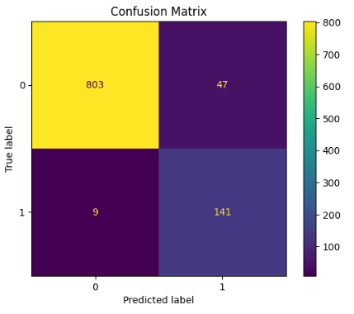
Fig: Confusion Matrix for Logistic Regression

KNN Classifier
The K-Nearest Neighbors (KNN) model was trained to classify sepsis and non-sepsis cases based on patient vital signs. The model achieved an accuracy of 95.4%, precision of 0.792, recall of 0.94, F1-score of 0.8598, and ROC-AUC of 0.9807, indicating strong classification performance. The confusion matrix shows that the model correctly identified most patient cases with very few misclassifications, demonstrating that KNN is effective for detecting sepsis patterns in the dataset.

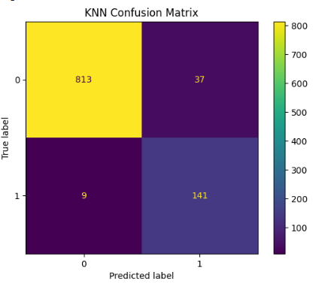
Fig: Confusion Matrix for KNN Classifier

Naïve Bayes
The Gaussian Naïve Bayes model was implemented to classify sepsis cases using the selected physiological features. The model achieved an accuracy of 93.8%, precision of 0.729, recall of 0.933, F1-score of 0.818, and ROC-AUC of 0.9876, indicating good predictive performance. The confusion matrix shows that the model correctly classified most patient cases with only a few misclassifications, demonstrating that Naïve Bayes can effectively capture probabilistic relationships in the dataset for sepsis prediction.

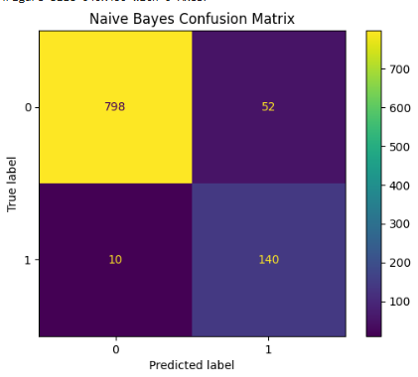
Fig: Confusion Matrix for Naïve Bayes Algorithm

Support Vector Machine
The Support Vector Machine model was trained to classify sepsis and non-sepsis cases using patient vital sign features. The model achieved an accuracy of 96.7%, precision of 0.842, recall of 0.96, F1-score of 0.897, and ROC-AUC of 0.993, indicating very strong classification performance. The confusion matrix shows that the model correctly identified most cases with very few false predictions, demonstrating that SVM is highly effective in distinguishing sepsis patterns in the dataset.

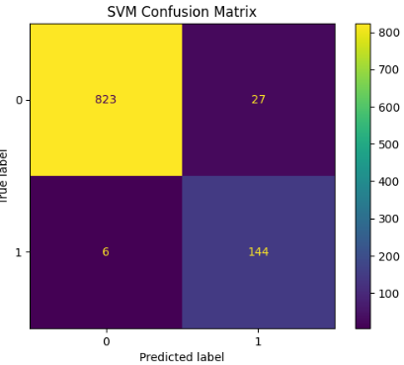
Fig: Confusion Matrix for Support Vector Machine

Decision Tree
The Decision Tree model was trained to classify sepsis cases based on patient vital sign features. The model achieved an accuracy of 93.6%, precision of 0.726, recall of 0.92, F1-score of 0.812, and ROC-AUC of 0.9697, indicating good predictive capability. The confusion matrix shows that most patient cases were correctly classified, although a few misclassifications occurred, demonstrating that the Decision Tree model can effectively capture decision rules for identifying sepsis patterns.
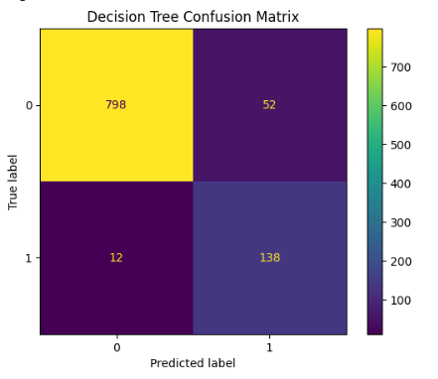
Fig: Confusion Matrix for Decision Tree

Random Forest Classifier
The Random Forest model was trained to predict sepsis using patient vital sign features. The model achieved an accuracy of 97.4%, precision of 0.913, recall of 0.913, F1-score of 0.913, and ROC-AUC of 0.991, indicating excellent predictive performance compared to other models. The confusion matrix shows that most cases were correctly classified with very few false predictions, demonstrating that the Random Forest model provides robust and reliable classification for sepsis detection.

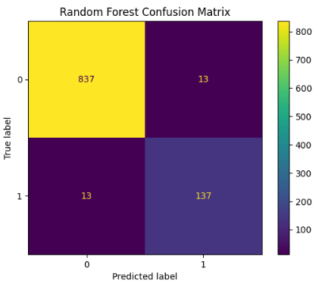
Fig: Confusion Matrix for Random Forest Classifier

XGBoost
The XGBoost model was implemented to classify sepsis and non-sepsis cases using patient vital sign features. The model achieved an accuracy of 97.3%, precision of 0.907, recall of 0.913, F1-score of 0.910, and ROC-AUC of 0.990, indicating very strong predictive performance. The confusion matrix shows that the model correctly classified the majority of cases with minimal misclassifications, demonstrating that XGBoost is highly effective for sepsis prediction.
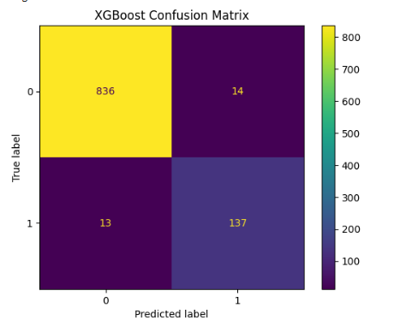
Fig: Confusion Matrix for XGBoost

MLP Neural Network
The Multilayer Perceptron (MLP) neural network was trained to predict sepsis using patient vital sign features. The model achieved an accuracy of 96.5%, precision of 0.840, recall of 0.947, F1-score of 0.890, and ROC-AUC of 0.994, indicating strong predictive performance. The confusion matrix shows that the model correctly classified most patient cases with very few misclassifications, demonstrating that the MLP model effectively captures complex patterns in the dataset for sepsis prediction.

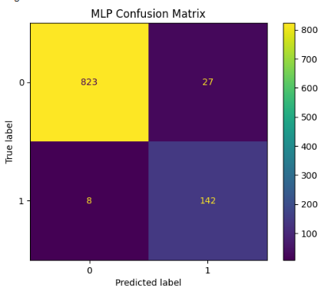
Fig: Confusion Matrix for MLP Neural Network

Deep Neural Network
The Deep Neural Network (DNN) model was trained to classify sepsis cases using patient vital sign features. The model achieved an accuracy of 97.0%, precision of 0.861, recall of 0.953, F1-score of 0.905, and ROC-AUC of 0.993, indicating very strong predictive performance. The confusion matrix shows that most patient cases were correctly classified with very few misclassifications, demonstrating that the DNN model effectively learns complex patterns in the dataset for accurate sepsis prediction.
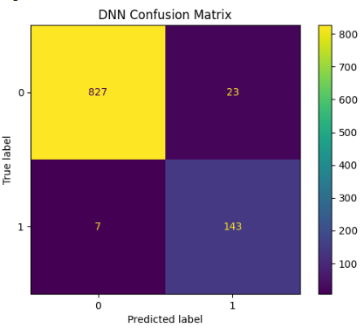
Fig: Confusion Matrix for Deep Neural Network

CONCLUSION AND FUTURE SCOPE
This project developed an Edge-AI based real-time sepsis prediction system that integrates physiological sensors, embedded hardware, and machine learning techniques for continuous patient monitoring in healthcare environments. Vital parameters such as heart rate, blood pressure, body temperature, oxygen saturation (SpO₂), and respiratory rate are collected using sensors connected to an Arduino Nano 33 BLE Sense, which acts as the data acquisition unit and transmits the data to a Raspberry Pi for edge processing. Multiple machine learning and deep learning models including Logistic Regression, KNN, Naive Bayes, SVM, Decision Tree, Random Forest, XGBoost, MLP, and DNN were trained and evaluated using an ICU dataset, and the Random Forest model demonstrated the best predictive performance, leading to its deployment on the Raspberry Pi for real-time inference and early sepsis risk detection. The proposed system enables low-latency analysis, improved data privacy, and continuous monitoring, which can support healthcare professionals in making timely clinical decisions. In the future, the system can be enhanced by integrating additional biosensors, advanced deep learning models such as LSTM for time-series analysis, and real-time monitoring dashboards or mobile applications, as well as by incorporating cloud connectivity and hospital information systems to enable large-scale deployment and more comprehensive intelligent healthcare monitoring.

REFERENCES
[1] H. Henry et al., “A targeted real-time early warning score for septic shock,” Sci. Transl. Med., 2015.
[2] A. Reyna et al., “Early prediction of sepsis using machine learning,” Nat. Med., 2019.
[3] Z. Wang et al., “Clinical decision support system for sepsis prediction using Attention-LSTM,” IEEE Access, 2020.
[4] M. Nemati et al., “Interpretable machine learning model for sepsis prediction in ICU,” Crit. Care Med., 2018.
[5] R. Desautels et al., “Prediction of sepsis in ICU with electronic health record data,” IEEE J. Biomed. Health Inform., 2016.
[6] S. Futoma et al., “Learning to detect sepsis with RNN
models,” Proc. ICML, 2017.
[7] M. Shashikumar et al., “Early sepsis detection using deep learning,” IEEE J. Biomed. Health Inform., 2020.
[8] J. Delahanty et al., “Machine learning model for early identification of sepsis,” Ann. Emerg. Med., 2019.
[9] A. Tomašev et al., “Continuous prediction of acute conditions using deep learning,” Nature, 2019.
[10] Y. Li et al., “Artificial intelligence based early diagnosis of sepsis,” J. Biomed. Inform., 2019.
[11] A. Moor et al., “Early recognition of sepsis with machine learning,” J. Clin. Monit. Comput., 2021.
[12] K. Kamaleswaran et al., “Multimodal deep learning for neonatal sepsis prediction,” IEEE J. Biomed. Health Inform., 2020.
[13] R. Fleuren et al., “Machine learning for sepsis prediction: A systematic review,” Intensive Care Med., 2020.
[14] M. Taylor et al., “Explainable AI for critical care sepsis prediction,” Artif. Intell. Med., 2021.

